

Undergraduate Lab Report

Course Title: Experiment of Computer Organization
Course No: 60080014
Student Name: 蒋云翔
Student No: 2022102330
School: 暨南大学
Department: 国际学院
Major: CST
Instructor： SUN Heng

Academic Year:2022 ~2023,Semester : 1st [ √ ] 2nd[ ]

Academic Affairs Office of Jinan University
Date (dd/mm/yyyy)___07/11/2023_____
Computer Organization Lab List
Student Name: 蒋云翔 Student No: 2022102330

ID | Lab Name | Type
1 | Number Storage Lab | Individual
2 | Manipulating Bits | Individual
3 | Simulating Y86-64 Program | Individual
4 | Performance Lab | Team
5 | A Simple Real-life Control System | Team
6 | System I/O | Individual
Undergraduate Lab Report of Jinan University
Course Title Experiment of Computer Organization Evaluation
Lab Name Simulating Y86-64 Program Instructor Sun Heng
Lab Address Room116
Student Name 蒋云翔 Student No 2022102330
College 国际学院
Department Major CST
Date 07 / 11 / 2023 Morning / Afternoon
- Introduction
In this lab, you will learn about the implementation of a Y86-64 processor. When completing this lab, you will have a keen appreciation for the interactions between instruction and hardware that affect your programs. You will run two simple Y86-64 programs and become familiar with the Y86-64 tools.
- Lab Instructions or Steps
You will be working in directory sim/misc in this part. Your task is to simulate the following two Y86-64 programs. The required behavior of these programs is defined by the example C functions in sim\misc\examples.c.
Testing the program. The Y86-64 assembler takes a Y86-64 assembly code file with extension .ys and generates a file with extension .yo. Put rsum.ys and sum.ys into misc directory.
- Lab Device or Environment
VMware Workstation Pro17 & Ubuntu 16.04
- Results and Analysis
- Sum.yo
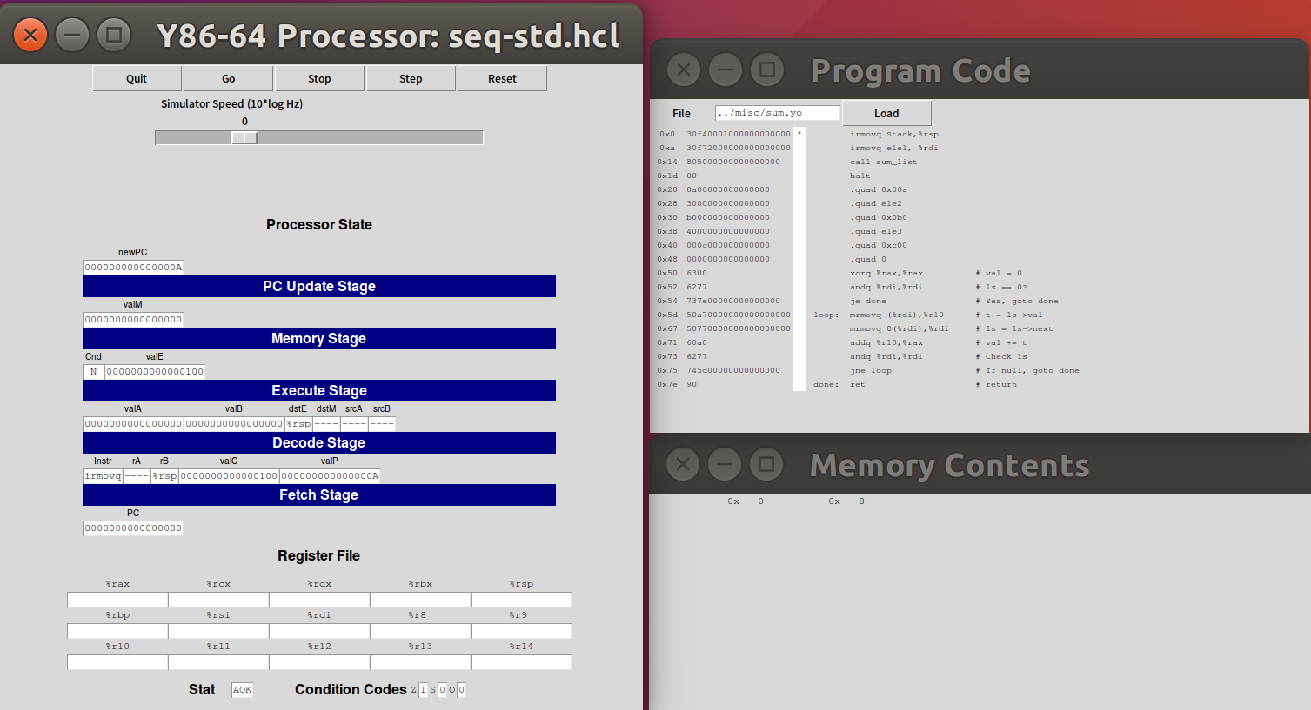
This instruction sets the value of the Stack pointer %rsp to the memory address represented by the stack label.

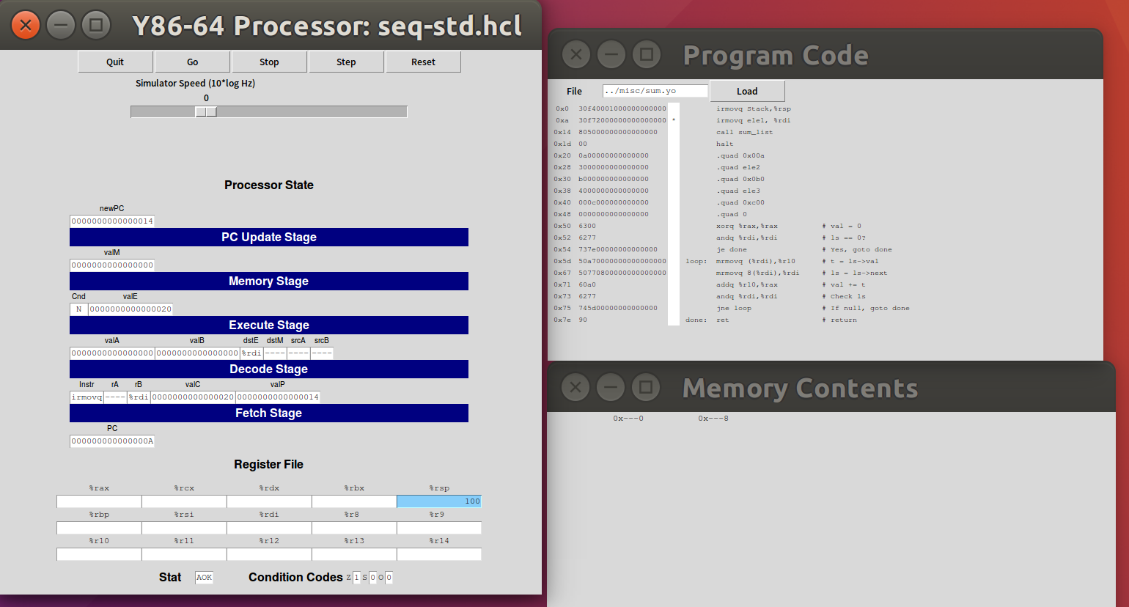
This instruction loads the value of the memory address represented by the ele1 tag into the %rdi register.

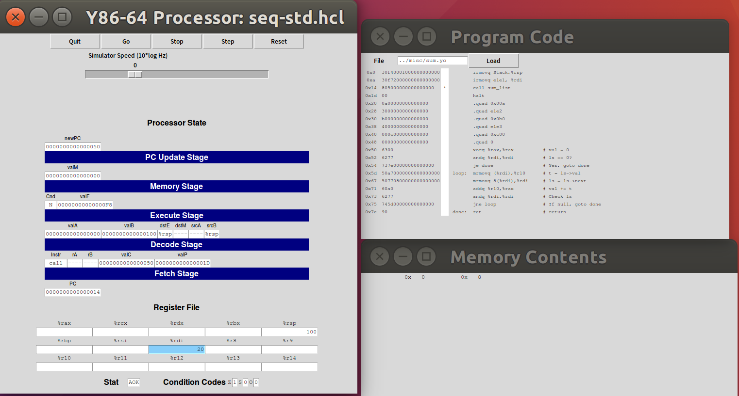
This instruction calls sum_ List function. It saves the current program flow onto the stack and jumps to sum_ The code for the list function starts executing.

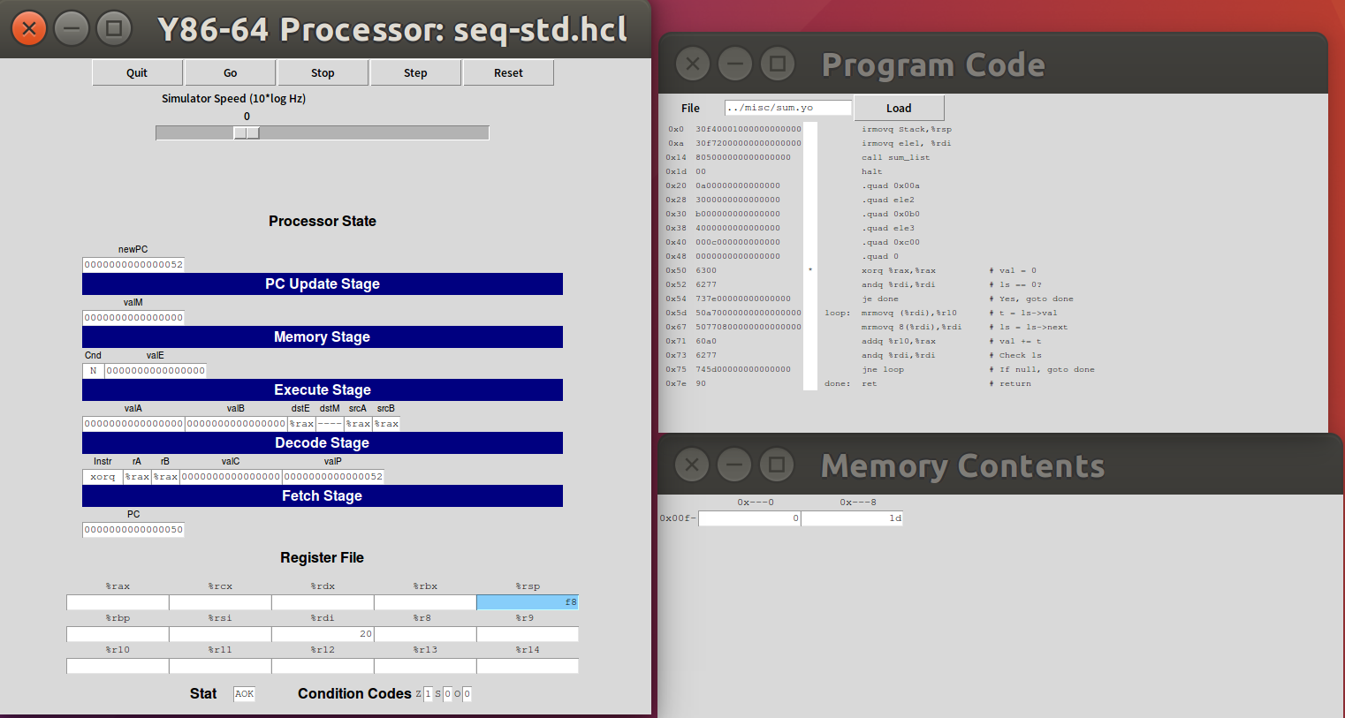
Xorq% rax,% rax clears the% rax register to zero as an accumulator.

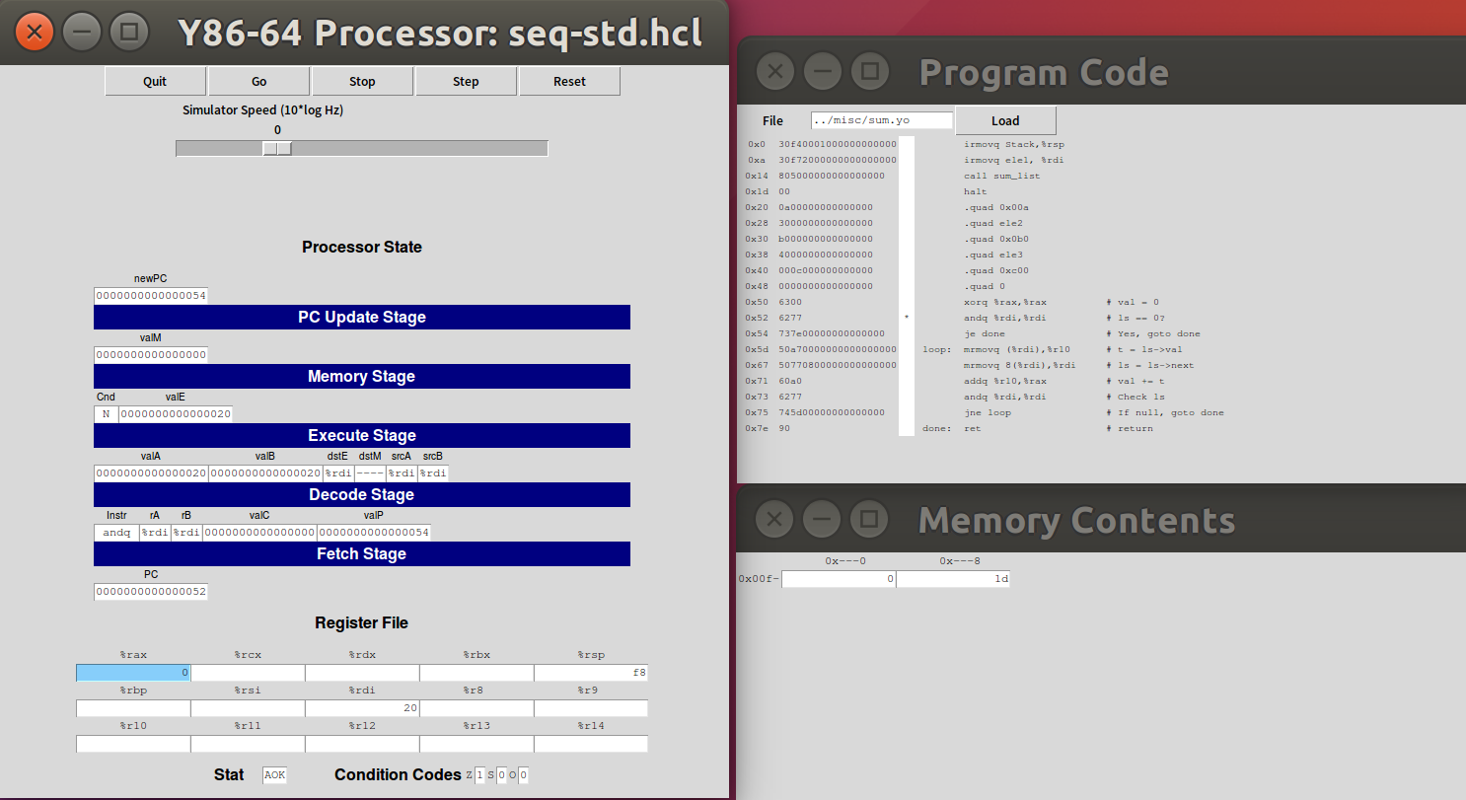
By using andq% rdi,% rdi checks whether the value in the% rdi register is zero, which determines whether the linked list is empty. If the linked list is empty, jump to the done label and return the result.

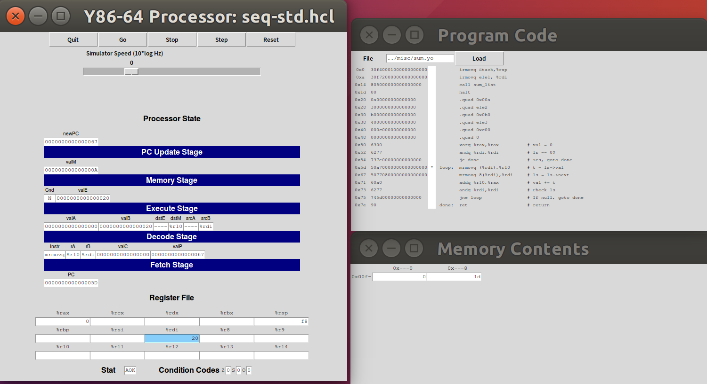
This part is the loop part of the sum_list function. In each iteration, first via mrmovq (%rdi),%r10 loads a 64-bit value into the %r10 register from the address pointed to by the %rdi register, representing the value of the current node. Then, with mrmovq 8(%rdi),%rdi loads the address of the next node from the address pointed to by the %rdi+8 register into the %rdi register, updating %rdi to the address of the next node. Next, by addq %r10,%rax adds the values in the %r10 register to the %rax register, which adds the sum. Finally, by andq %rdi,%rdi checks whether the value in the %rdi register is zero, that is, whether the list has been traversed. If it is not zero, there is another node, jump to the loop TAB to continue the next loop. If it is zero, it indicates that the list has been traversed, and the result is returned by jumping to the done tag.

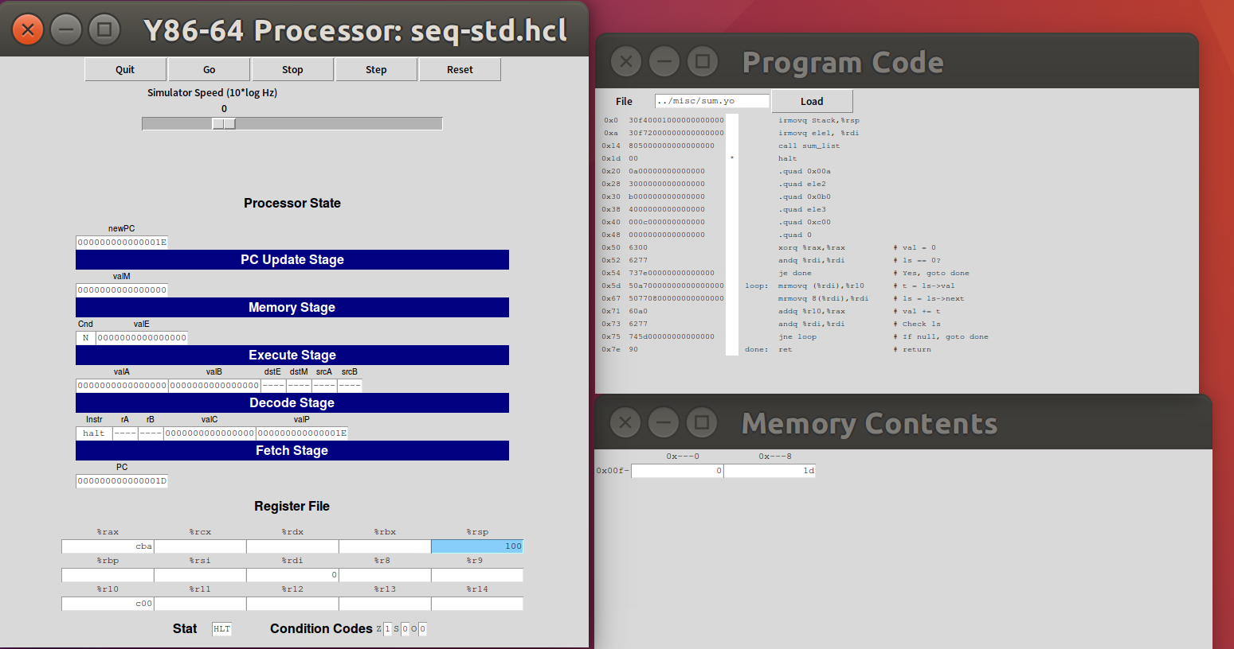
Loop is over. This instruction tells the processor to stop executing the program.

- Rsum.yo
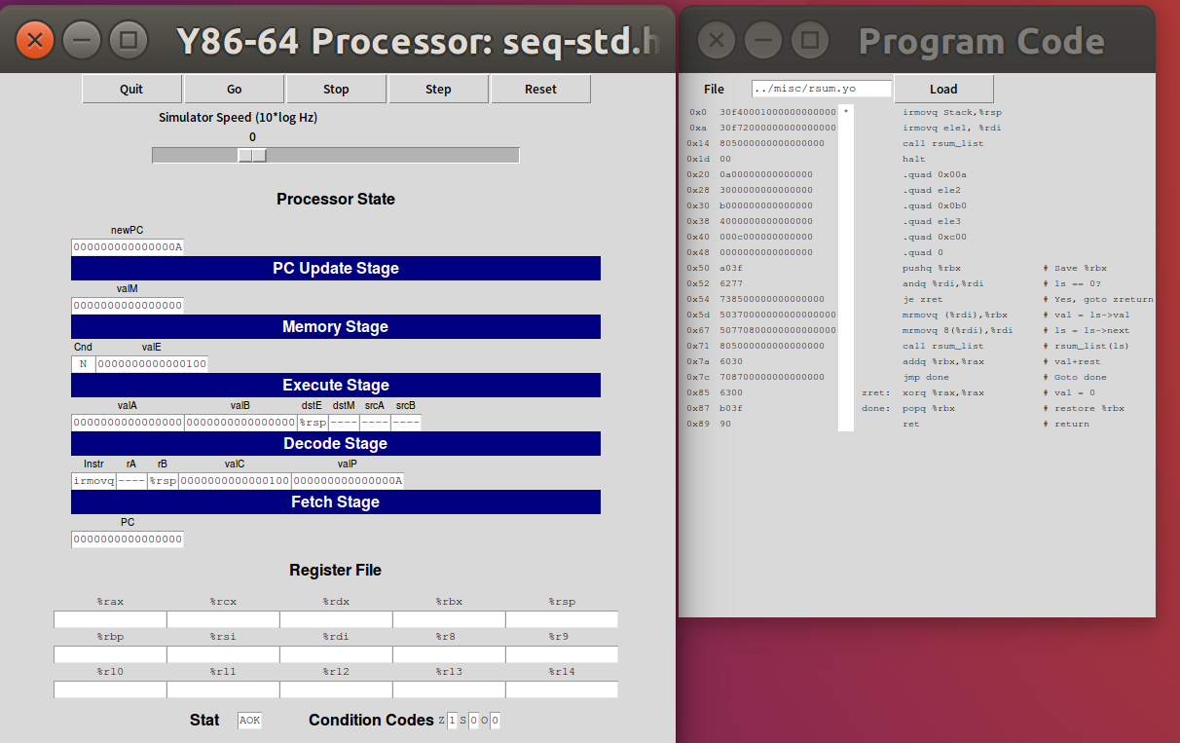
This instruction sets the value of the Stack pointer %rsp to the memory address represented by the stack label.

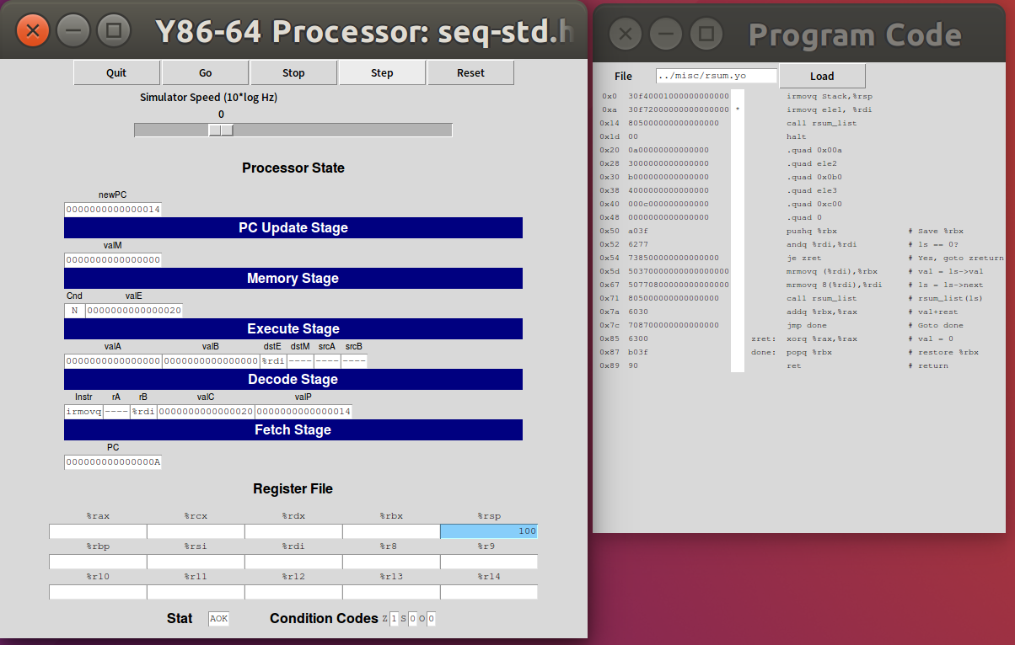
This instruction loads the value of the memory address represented by the ele1 tag into the %rdi register.

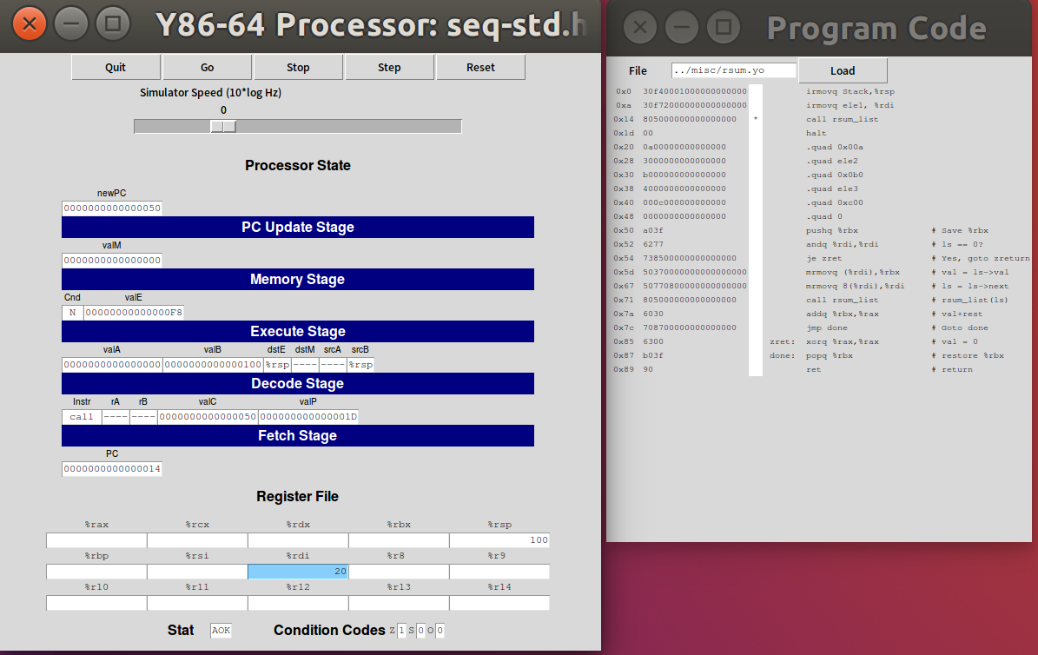
This directive calls the rsum_list function. It saves the current program flow onto the stack, and the code that jumps to the rsum_list function starts executing.

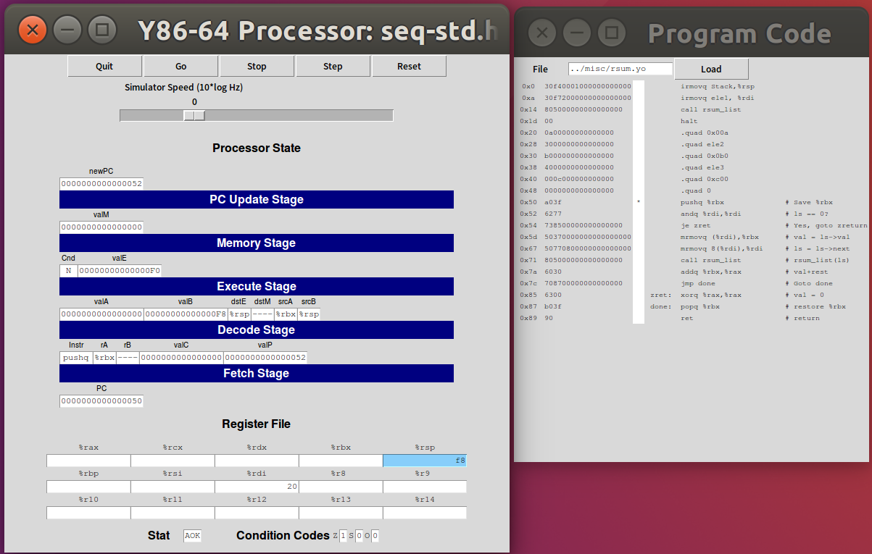
The explanation of the whole function rsum_list:
This part is the implementation of the rsum_list function. First, it saves the value of the %rbx register (using pushq %rbx), then checks if the parameter ls is zero, and if so, returns 0 directly; Otherwise, recursively compute the sum of the values of the linked list nodes. On each recursive call, it adds the value of the current node to the resulting register %rax. Finally, it restores the value of the %rbx register (using popq %rbx) and returns the result.

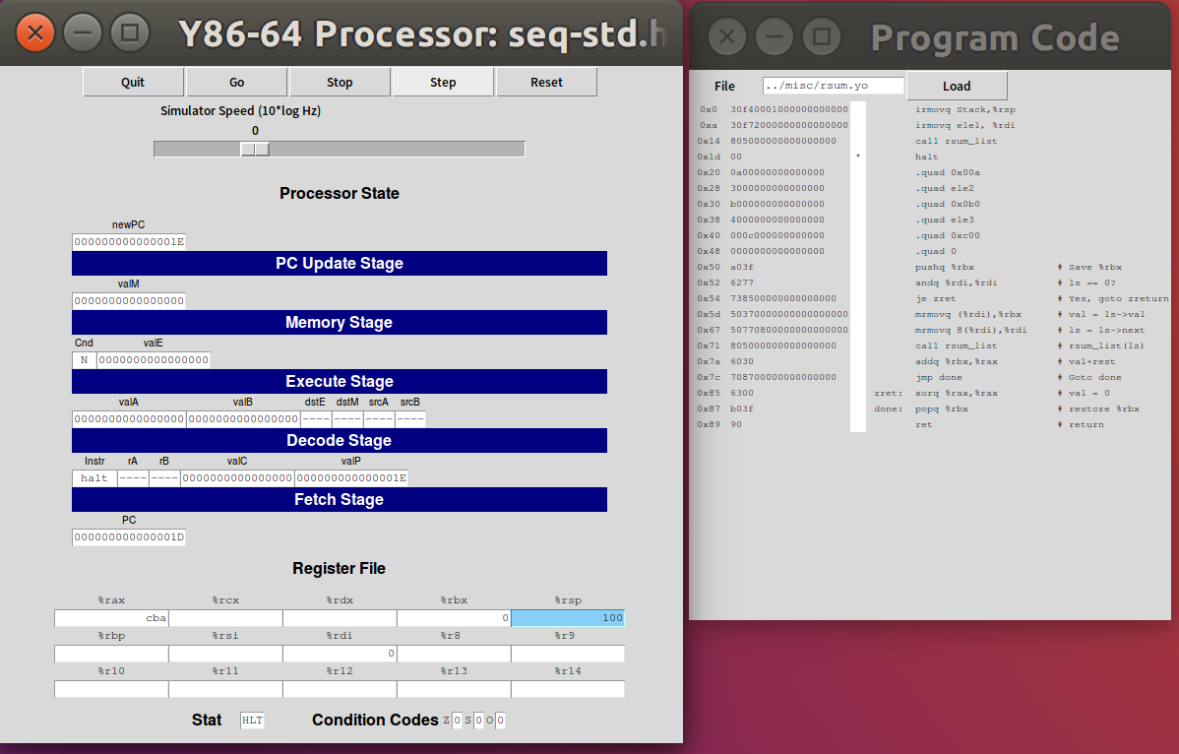
The recursive process is over. The sum has been stored.

- Appendix (Program Code)
- As for sum.ys
# Initial code
irmovq Stack,%rsp # Set the stack pointer to the address of the Stack
irmovq ele1, %rdi # Load the address of ele1 into the %rdi register as the argument
call sum_list # Call the sum_list function
halt # Halt the processor

# Sample linked list
.align 8 # Align the following data on an 8-byte boundary
ele1:
.quad 0x00a # Value of the first element in the linked list
.quad ele2 # Address of the next element, ele2
ele2:
.quad 0x0b0 # Value of the second element in the linked list
.quad ele3 # Address of the next element, ele3
ele3:
.quad 0xc00 # Value of the third element in the linked list
.quad 0 # Address of the next element, indicating the end of the list

# long sum_list(list_ptr ls)
# ls in %rdi
sum_list:
xorq %rax,%rax # Initialize the sum (val) to 0
andq %rdi,%rdi # Check if ls is equal to 0
je done # If ls is 0, jump to done
loop:
mrmovq (%rdi),%r10 # Load the value of ls->val into register %r10
mrmovq 8(%rdi),%rdi # Update ls to ls->next
addq %r10,%rax # Add the value of t to the sum (val)
andq %rdi,%rdi # Check if ls is null
jne loop # If ls is not null, jump to loop
done:
ret # Return from the function

.pos 0x100 # Set the memory position to 0x100
Stack: # Define the start of the stack

- As for rsum.ys
# Initial code
irmovq Stack,%rsp # Set the stack pointer to the address of the Stack
irmovq ele1, %rdi # Load the address of ele1 into the %rdi register as the argument
call rsum_list # Call the rsum_list function
halt # Halt the processor

# Sample linked list
.align 8 # Align the following data on an 8-byte boundary
ele1:
.quad 0x00a # Value of the first element in the linked list
.quad ele2 # Address of the next element, ele2
ele2:
.quad 0x0b0 # Value of the second element in the linked list
.quad ele3 # Address of the next element, ele3
ele3:
.quad 0xc00 # Value of the third element in the linked list
.quad 0 # Address of the next element, indicating the end of the list

# long rsum_list(list_ptr ls)
# ls in %rdi
rsum_list:
pushq %rbx # Save the value of %rbx onto the stack
andq %rdi,%rdi # Check if ls is equal to 0
je zret # If ls is 0, jump to zreturn
mrmovq (%rdi),%rbx # Load the value of ls->val into register %rbx
mrmovq 8(%rdi),%rdi # Update ls to ls->next
call rsum_list # Recursively call rsum_list(ls)
addq %rbx,%rax # Add val to the result of the recursive call
jmp done # Jump to done
zret:
xorq %rax,%rax # Set the result (val) to 0
done:
popq %rbx # Restore the value of %rbx from the stack
ret # Return from the function

.pos 0x100 # Set the memory position to 0x100
Stack: # Define the start of the stack

